**COMPUTER NETWORKS**

**Task 12**



**Submitted To: Sir Rasikh**

**Submitted By: Muhammad Saad**

**Submitted On: 23/11/24**

**BSSEM-F22-069-5B**

**Department of Software Engineering,**

**Superior University, Lahore**

**Question 1: Configure VLAN & Inter-VLAN Routing**

**Answer:**

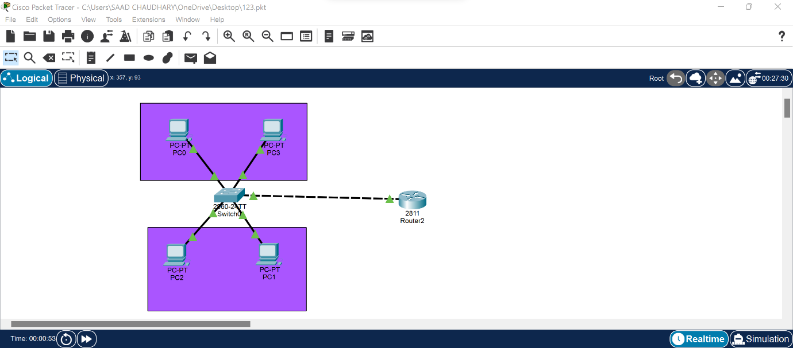

**Question 2: What is difference between “VLAN & Inter-VLAN Routing”, explain with Example**

**Answer:**

The main difference between VLAN and inter-VLAN routing is that VLAN is a way to logically divide a network into smaller segments, while inter-VLAN routing is the process of enabling communication between those segments:

* **VLAN**

Stands for virtual local area network. It's a way to divide a physical network into smaller segments based on criteria like function, department, or security level.

* **Inter-VLAN routing**

The process of enabling communication between different VLANs on the same or different switches. It's necessary to allow some traffic to flow between VLANs so certain services and systems are available on any network segment.

You can implement inter-VLAN routing using a router or a layer 3 switch. For example, on a smart switch, you can set up inter-VLAN routing by creating a Layer 3 interface, also known as a switch virtual interface (SVI).

An example of how VLANs can be used is to put all desktop voice over IP phones on one VLAN and all workstations on another. In this case, the phones won't see any workstation-generated broadcast traffic and vice versa.